DATE: May 25, 2018
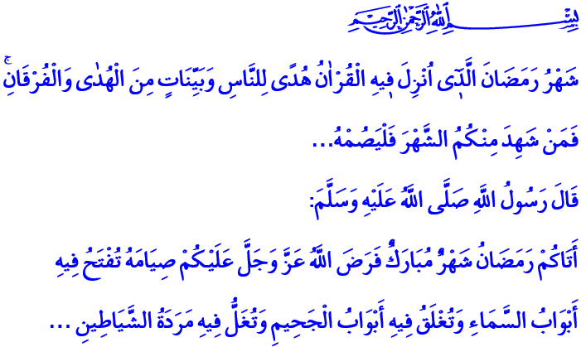
RAMADAN: THE MONTH OF FASTING AND QUR’AN
Honorable Believers!
It had been eighteen months after Our Prophet Muhammad (s.a.w) migrated to Medina. It was the last days of the month of Shaban. The following verses of the Surah al-Baqarah were revealed, which informed that fasting in Ramadan was made obligatory:
“The month of Ramadhan [is that] in which was revealed the Qur’an, a guidance for the people and clear proofs of guidance and criterion. So whoever sights [the new moon of] the month, let him fast it.”
Our beloved Prophet (s.a.w.) also addressed the Ummah on the pulpit at the Masjid al-Nabawi as, “There has come to you Ramadan, a blessed month, which Allah, the Mighty and Sublime, has enjoined you to fast. In it the gates of heavens are opened and the gates of Hell are closed, and every devil is chained up.”
Dear Believers!
Ramadan, the sultan of eleven months, has a special place in our spiritual life. For Ramadan is the month of fasting and Qur’an. Ramadan is the month of patience, gratitude, repentance and contemplation. Ramadan is the most honorable month, including the Night of Qadr inside, which is more blessed than a thousand months. Ramadan means worship, abundance, and mercy. Ramadan means obedience, benevolence, and benefaction. As Our Prophet informed, an angel calls on the first night of Ramadan, “O seeker of the good; come near (to worship and servitude)! And, O seeker of evil; stop (committing sins)!”
Brothers and Sisters!
Ramadan finds meaning with fasting. Our fasting, first of all, is a training for patience, willpower, and mercy. It is a shield that protects us from being enslaved by lust and whims, illicit relishes and desires. The following verse indicates that the purpose in fasting is to abstain from all kinds of evil and sins, “O you who have believed, decreed upon you is fasting as it was decreed upon those before you that you may become righteous.” Indeed, Rasulullah (s.a.w.) enjoins, “Fasting is a shield. So, the person fasting should avoid saying bad words and fighting. And if anyone fights or quarrels with him, he should say, ‘I am fasting.’ ”
Esteemed Believers!
Ramadan is the month when the Qur’an, our book of life, started being revealed. The Qur’an is the word of Allah, the book of Allah. It is “The most beautiful statement” as it came from Allah. As expressed by our Prophet, “The truest of word is the Book of Allah, and best of guidance is the guidance of Muhammad.” The Holy Qur’an is the guide that shows the truest path to people in all epochs and in all regions until the last day. The Qur’an is a cure for souls and mercy for hearts. The Qur’an teaches us Our Lord, informs us of our responsibilities, and reminds us of the afterlife. It teaches the meaning of being a human and secrets to live in a humane way.
Honorable Muslims!
Ramadan is the month of brotherhood, solidarity, and sharing. When we temporarily abstain from eating and drinking, we sympathize with the poor, we appreciate what we have, and we realize that we need to duly be grateful to Allah, the Sustainer (al-Razzaq).
Ramadan is also a chance to quit bad habits, and to open a new page for what is good and beautiful. Thanks to Ramadan, we exert ourselves for charity, we invest in goodness, and we stay away from bad words and deeds. We heartily feel unity, solidarity and brotherhood. Our ties of love and respect strengthen. Awards and rewards of worshipping, charity and benevolence, performed in this month, are more than that of other months.
Dear Brothers and Sisters!
So, let us introduce our tongues, hearts, minds and all our lives to the beauties of Ramadan and fasting. Let us make time for reading and understanding the Holy Qur’an more than ever. Let us repair our worn-out hearts and minds with the light of the Qur’an. Let us fast with awareness. Let us make our tongues, hands, eyes, hearts and all parts of us fast, not only our stomach, such that it protects us from all evil.
Brothers and Sisters!
The primary one of the important activities of Turkiye Diyanet Foundation is educational services. Our foundation carries out educational activities both at home and abroad in order to raise generations who truly understand and live Islam. It provides stipends and educational support for thousands of students from 111 countries within the framework of Qur’an Courses, International Imam-Khatib and Theology programs. Today, in all mosques throughout the country, you, dear Muslims, will be asked for donations to be used in educational activities. Also, you can include your zakat and fitra within these donations. May Our Lord accept the donation you have made and will make.
I would like to conclude this khutbah with this hadith of Our Prophet (s.a.w.): “Whoever establishes prayers during the nights of Ramadan faithfully out of sincere faith and hoping to attain Allah's rewards, all his past sins will be forgiven.”

Baqarah, 2/185.
Nasa’i, Siyam, 5.
Tirmidhi, Sawm,1; Ibn Majah, Siyam, 2.
Baqarah, 2/183.
Bukhari, Sawm, 9; Muslim, Siyam, 29.
Zumar, 39/23.
Nasa’i, Salat al-‘Idayn, 22.
Bukhari, Iman, 27. General Directorate of Religious Services

